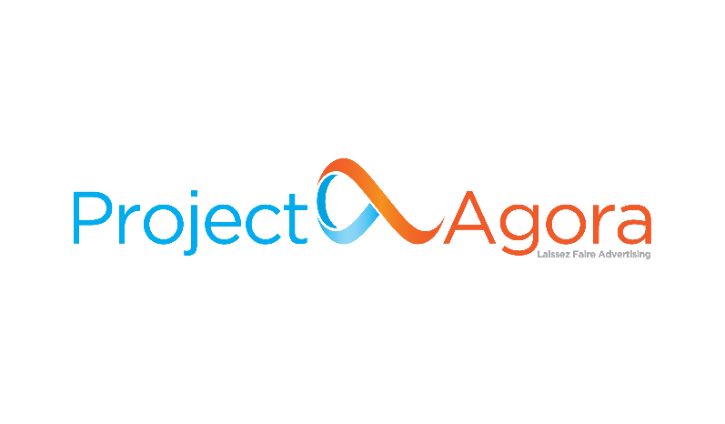

**Technical Support Executive**

[**Project Agora**](http://www.projectagora.com/)**,** a [**TDG (ThinkDigital Group)**](https://thinkdigitalgroup.net/) company, is a Media Technology SaaS on a mission to keep the **Open Web Open**. In our day-to-day, we work with over 2000 top digital Publishers and E-tailers in EMEA and LATAM, supporting them to maximize the value of each visitor, managing 11.5 billion impressions per month. 

Project Agora has enjoyed a steady growth of more than 50% a year since its founding in 2014. Our teams are an extraordinary group of talented, active, and innovative people who care about more than just building cutting edge technologies. We challenge ourselves to work with the best. We live and define our work ethics by our core values. We are **Fat Cow Killers** improving process efficiency, **Rainmakers**bringing stunning results, **I+Valuers** supporting colleagues, customers and partners, **Always Curious** exploring ways to innovate and we have **Positive Bigfoots** carrying self-sustainable digital minded happiness to other people.

**Your Impact**

To join us on our mission to keep the Open Web Open, we are looking for a talented **Technical Support Executive**. The successful candidate will have the opportunity to work at the forefront of the advertising industry, as a member of our Support Team, and provide accurate solutions to our Publishers.

Being part of a fast-growing scale-up organization, the role requires a self-starting, results-oriented and passionate professional to be instrumental in providing technical support to our clients.

The successful candidate will join TDG’s Tech Hub in Patras and will work closely with internal teams including Product, Success and Development.

Come join us and help keep the Open Web Open.

**Key Responsibilities**

* Onboard Project Agora products for all our new and existing Publishers.
* Provide technical support to our clients.
* Handle communication with all our Publishers through our ticketing system.
* Manage individual deliverables and meet our team’s KPIs.
* Work with internal (Success, Product, Development Departments) and external teams in order to provide solutions.

**We’re looking for someone who**

* Holds a Bachelor’s Degree in **Computer Science**, Information Systems or another related field.
* Is familiar with **web technologies** and languages including HTML, CSS, JavaScript.
* Displays excellent communication skills in English, both written and verbal.
* Is fully developed Customer Service Skills.
* Is able to prioritize and deliver to strict deadlines.
* Is a voracious learner, having the desire and ability to become a deep expert in hundreds of use cases across multiple products.

**Nice to Have**

Knowledge of the Spanish language (or native speaker) will be a plus.

**Who you will be working with**

* A team with a great working culture that embraces autonomy and initiative-taking, supporting local media owners against international goliaths.
* A highly skilled engineers’ team organized in a specific structure, interacting with numerous UIs and tools.

**Personal Objectives**

* Gain deep knowledge of our products covering hundreds of use cases and offer excellent customer services.
* Develop communication skills to efficiently provide our Publishers with your feedback.
* Become an expert in learning new products and ad technologies.

**Benefits and Perks**

**Project Agora** company is part of **TDG**, recognized as a [**Great Place to Work® for 2022**](https://www.greatplacetowork.gr/certified-companies/thinkdigital-group/). We are on a mission to boldly lead our people to where no one has gone before. Our people enjoy benefits that make them able to develop their careers and professional skills. We challenge ourselves to work with the best and most talented professionals and we want to offer a great place to work and thrive. We are offering:

* A competitive salary based on experience and skills.
* A budgeted training and professional development plan.
* A modern workplace environment, and the excitement of working closely with a successful, highly motivated, dynamic, and talented team.
* Heart Long Weekends! A paid-time-off throughout the year to enjoy life outside of work.
* Health insurance scheme.
* Access to TDG’s Library for professional development.
* Fresh fruits & best selection of tea every day.

**Additional Information**

* Τype: **Full-time**
* Seniority Level: **Junior**
* Reports to: **Technical Support Manager**
* Location: **Patras, Greece**

Project Agora offers a hybrid working model. Team members all over the EMEA region currently can meet in person. Project Agora continues to grow our team by conducting a remote-first onboarding process.

**You can apply for this job at the link** [**here**](https://tdg.bamboohr.com/jobs/view.php?id=180)**.**

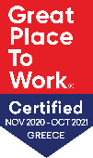TDG is certified as one of the great  
working environments in Greece for 2021.

Read more [here](https://thinkdigitalgroup.net/thinkdigital-group-is-a-great-place-to-work/).