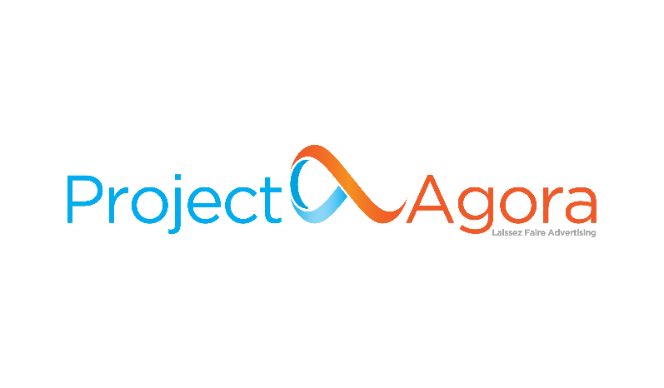

**Junior Business Intelligence Analyst**

[**Project Agora**](http://www.projectagora.com/), a [**TDG (ThinkDigital Group)**](https://thinkdigitalgroup.net/) company, is a Media Technology SaaS on a mission to keep the **Open Web Open**. In our day-to-day, we work with over 2700 top local digital Publishers and e-Retailers in EMEA and LATAM, supporting them to maximize the value of each visitor.

Project Agora has been named as one of the 1.000 fastest growing companies in Europe by the Financial Times, enjoying an annual growth of more than 80% every year since 2017. Our teams are an extraordinary group of talented, active, and innovative people who care about more than just building cutting edge technology. We live and define our work ethics by our core values. We are **Rainmakers** bringing stunning results, **I+Valuers** supporting colleagues, customers and partners and **Fat Cow Killers** striving to take inefficiency out of the way. Innate **Curious** we always explore ways to understand root causes and innovate and **Positive Bigfoots** carrying self-sustainable digital minded happiness to other people.

**Your Impact**

To join us on our mission to keep the Open Web Open, we are looking for a talented **Junior Business Intelligence Analyst**to join the Data Analytics team. In this role, you will join an established and fast-paced environment to drive action out of insights and work with cross-functional teams to drive business value. Within our growing organization, you will have the opportunity to work together with 80+ engineers and become part of one of the leading Ad-Tech companies in EMEA. You will focus on researching, developing and discovering new ways of providing solutions with our tools.

Being part of a fast-growing scale-up organization and working in the BI Team, the role requires an agile, curious and dynamic professional with good business acumen to manage multiple projects.

The successful candidate has the flexibility to be based in Athens at TDG’s Headquarters or at TDG’s Tech Hub in Patras or to work remotely.

**Key Responsibilities**

* Build small to mid-size business intelligence (BI) solutions – data sets, queries, reports, dashboards, analysis – or components of larger solutions to provide key revenue trends and metrics to ensure data-driven business decisions across the company
* Collaborate with the development team in defining, designing and implementing end to end BI projects.
* Assist in building data warehouse-oriented data pipelines (ETL, ELT etc.).
* Work with multiple and different data sources.
* Run Unit tests and ensure the QA of every deliverable project.
* Participate in gathering requirements from the stakeholders.
* Participate in multiple projects at a time in a fast-paced, intense, data-driven and results-oriented environment.

**We’re looking for someone who**

* Holds a bachelor’s degree in Computer Science or Engineering.
* Is familiar with SQL, Data Analytics, Reporting, Data warehousing, Relational & Dimensional database architectures.
* Has excellent communication skills in Greek and English, both written and verbal.
* Is willing to learn and constantly keep up with trends and best practices.

**Big Plus**

* Experience with Microsoft SQL Server and SQL Server Integration Services (SSIS).
* Experience in Tableau or other visualization tools
* Familiar with developing API Services/Clients.
* Familiar with one or more languages (Python/PHP etc.)
* Confident in one or more DBs – MS SQL Server, BigQuery, MySQL, PostgresSQL etc.
* Experience in technical writing and documentation.

**Benefits & Perks**

**Project Agora** company is part of **TDG**, recognized as a [**Great Place to Work® for 2022**](https://www.greatplacetowork.gr/certified-companies/thinkdigital-group/). We are on a mission to boldly lead our people to where no one has gone before. Our people enjoy benefits that make them able to develop their careers and professional skills. We challenge ourselves to work with the best and most talented professionals and we want to offer a great place to work and thrive. We are offering:

* A competitive salary based on experience and skills.
* A budgeted training and professional development plan.
* A modern workplace environment, and the excitement of working closely with a successful, highly motivated, dynamic, and talented team.
* Heart Long Weekends! A paid-time-off throughout the year to enjoy life outside of work.
* Health insurance scheme.
* Access to TDG’s Library for professional development.
* Fresh fruits & best selection of tea every day.

**Additional Information**

* Τype: **Full-time**
* Reports to: **Data Analytics Manager**
* Location: **Remote or based in Athens or Patras, Greece**

Project Agora offers a hybrid working model. Team members all over the EMEA region currently can meet in person every other week. Project Agora continues to grow our team by conducting a remote-first onboarding process.

**You can apply for this job at the link** [**here**](https://tdg.bamboohr.com/jobs/view.php?id=184)**.**

TDG is certified as one of the great  
working environments in Greece for 2022.

Read more [here](https://thinkdigitalgroup.net/tdg-has-been-certified-as-a-great-place-to-work-for-2022/)