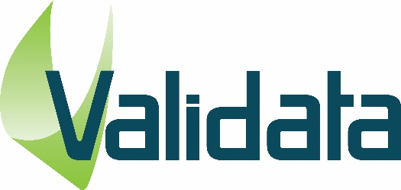

Are you studying computer science and looking for new and challenging tasks?

Do you want to put your academic knowledge into practice and shape the future with us in exciting software projects?

Do you want to learn more about new technologies and cutting-edge methods?

Then Validata is the right place for you as a working student or intern in our highly skilled dev team, where you can work on customer projects in a hands-on environment.

Validata Group is a fast growing multinational company providing testing and quality control for banking software and financial systems, and development of automated testing solutions.

**Skills & Technologies**

* Front-end or Back-end Development (C#, Python, JavaScript)
* Agile Development
* Cloud Technologies (Azure, Google)

**Profile**

* Studying computer science or a similar course of study
* Basic knowledge in software development
* Strong interest in new technologies
* Good knowledge of written and spoken English

**What we offer**

* Flexible working hours that can be adapted to your university schedule (20 hours a week would be great)
* A work laptop will be provided
* Attractive remuneration

To submit your application please send your CV to [recruit@validata-software.com](mailto:recruit@validata-software.com) with subject ‘WorkStudent0622’